Developing an NLP Model for Efficient Summarization of Legal and Financial Documents

1. INTRODUCTION:
The availability and ease of access of huge amounts of text data on the web presents both an opportunity as well as a challenge. Increased accessibility of data has led to the information overload problem. Huge research efforts have been expended on facilitating the automatic processing of such texts available online. An important task in the domain of natural language understanding is document summarization – i.e. condensing the contents of text to a concise form capturing only essential concepts in the document. Automatic summarization in legal domain can have a plethora of applications from simplifying the work of lawyers ploughing through a huge body of legal documents to efficient retrieval of judgments relevant to a query.
Document Summarization Methods are normally based on two approaches – abstractive and extractive Abstractive summarization techniques produce summaries covering the basic ideas expressed in the document mimicking humans and producing contents not present in the original document possibly consisting of different linguistic structures. Extractive summarization techniques on the other hand identify and extract important portions from the document which are then copied verbatim into the summary. Abstractive summarization techniques are in general more challenging than extractive ones and are more demanding in terms of resources and algorithm complexity.
Research in the field of document summarization has been going on for the past many decades. Some approaches have been based on Topic Modelling and latent semantic analysis, LSA which are entirely based on the text in the document. Obtaining enriched data sets by leveraging on domain knowledge to improve the summarization results have been explored in some of the previous works. These methods are essentially unsupervised. Text summarization using indicator methods has also been used effectively. These methods represent each sentence by its features. Graph based methods along with TFIDF weighing scheme are used to extract features from sentences. Classical machine learning algorithms are then used in order to decide the importance of various sentences.
Automatic summarization is researched extensively by legal information scientists and proposed methods are based on wide ranging approaches. Most of these approaches focus on exploiting labelled data for document segmentation to produce summary or extracting features from text for inclusion in summary. Legal text summarization approaches are mostly extractive and can be presented as supervised learning approaches in the presence of sufficient labelled data. In legal domain such labelled data is unavailable and expensive to generate and hence researchers have proposed approaches to generate labelled training data from available un-labelled data. Automatic generation of labelled training data for legal text segmentation by exploiting domain knowledge was proposed in. In the proposed work we demonstrate entirely data driven labelled data set generation. We mitigate the problem of non-availability of labelled data by leveraging on human generated headnotes which are present in some of the judgment documents. Taking into account the huge success of text summarization schemes based on deep learning we explore various deep learning approaches for the task of extractive legal judgment summarization which does not rely on domain knowledge or domain experts for labelled data creation. We specifically test our methods on the Indian Supreme Court judgements from 1947 to 1993. We find that, these simple proposed techniques in addition to outperforming baseline also result in reasonably coherent summaries.

  - Objective of the project:
The availability of legal judgment documents in digital form offers numerous opportunities for information extraction and application. Automatic summarization of these legal texts is a crucial and a challenging task due to the unusual structure and high complexity of these documents. Previous approaches in this direction have relied on huge labelled datasets, using hand engineered features, leveraging on domain knowledge and focussed their attention on a narrow sub-domain for increased effectiveness. In this paper, we propose simple generic techniques using neural network for the summarization task for Indian legal judgment documents. We explore two neural network architectures for this task utilizing the word and sentence embeddings for capturing the semantics. The main advantage of the proposed approaches is that they do not rely on hand crafted features, or domain specific knowledge, nor is their application restricted to a particular sub-domain thus making them suitable to be extended to other domains as well. We tackle the problem of unavailability of labelled data for the task by assigning classes/scores to sentences in the training set, based on their match with reference summary produced by humans. The experimental evaluations establish the effectiveness of our proposed approaches as compared with other baselines.

2. LITERATURE SURVEY:
“Experimental investigating the F-measure as similarity measure for automatic text summarization”
This paper evaluates the performance of different similarity measures in the context of document summarization. For this purpose in this paper a simple and effective sentence extractive technique is used. The proposed method is based on evaluation of relevance score of sentence. Many measures are available for the calculation of inter sentence relationships. To calculate a similarity between sentences we use cosine measure and classical IR F-measure. We present a comprehensive experimental evaluation two different document collection. Our experimental results show that F-measure lead to the best overall results than cosine measure.
“Fast abstractive summarization with reinforce-selected sentence rewriting”
Inspired by how humans summarize long documents, we propose an accurate and fast summarization model that first selects salient sentences and then rewrites them abstractively (i.e., compresses and paraphrases) to generate a concise overall summary. We use a novel sentence-level policy gradient method to bridge the non-differentiable computation between these two neural networks in a hierarchical way, while maintaining language fluency. Empirically, we achieve the new state-of-the-art on all metrics (including human evaluation) on the CNN/Daily Mail dataset, as well as significantly higher abstractiveness scores. Moreover, by first operating at the sentence-level and then the word-level, we enable parallel decoding of our neural generative model that results in substantially faster (10-20x) inference speed as well as 4x faster training convergence than previous long-paragraph encoder-decoder models. We also demonstrate the generalization of our model on the test-only DUC-2002 dataset, where we achieve higher scores than a state-of-the-art model.
“Supervised learning of universal sentence representations from natural language inference data.”
Many modern NLP systems rely on word embeddings, previously trained in an unsupervised manner on large corpora, as base features. Efforts to obtain embeddings for larger chunks of text, such as sentences, have however not been so successful. Several attempts at learning unsupervised representations of sentences have not reached satisfactory enough performance to be widely adopted. In this paper, we show how universal sentence representations trained using the supervised data of the Stanford Natural Language Inference datasets can consistently outperform unsupervised methods like SkipThought vectors on a wide range of transfer tasks. Much like how computer vision uses ImageNet to obtain features, which can then be transferred to other tasks, our work tends to indicate the suitability of natural language inference for transfer learning to other NLP tasks. Our encoder is publicly available.
“General purpose unsupervised sentence representations.”
A lot of the recent success in natural language processing (NLP) has been driven by distributed vector representations of words trained on large amounts of text in an unsupervised manner. These representations are typically used as general purpose features for words across a range of NLP problems. However, extending this success to learning representations of sequences of words, such as sentences, remains an open problem. Recent work has explored unsupervised as well as supervised learning techniques with different training objectives to learn general purpose fixed-length sentence representations. In this work, we present a simple, effective multi-task learning framework for sentence representations that combines the inductive biases of diverse training objectives in a single model. We train this model on several data sources with multiple training objectives on over 100 million sentences. Extensive experiments demonstrate that sharing a single recurrent sentence encoder across weakly related tasks leads to consistent improvements over previous methods. We present substantial improvements in the context of transfer learning and low-resource settings using our learned general-purpose representations.
“Summarization of legal texts with high cohesion and automatic compression rate”
We describe a method for extractive summarization of legal judgments using our own graph-based summarization algorithm. In contrast to the connected and undirected graphs of previous work, we construct directed and disconnected graphs (a set of connected graphs) for each document, where each connected graph indicates a cluster that shares one topic in a document. Our method automatically chooses the number of representative sentences with coherence for summarization, and we don’t need to provide a priori, the desired compression rate. We also propose our own node/edge-weighting scheme in the graph. Furthermore, we do not depend on expensive hand-crafted linguistic features or resources. Our experimental results show our method outperforms previous clustering-based methods, including those which use TF*IDF-based and centroid-based sentence selection. Our experimental results also show that our method outperforms previous machine learning methods that exploit a variety of linguistic features.
“Minimum redundancy and maximum relevance for single and multi-document Arabic text summarization”
Automatic text summarization aims to produce summaries for one or more texts using machine techniques. In this paper, we propose a novel statistical summarization system for Arabic texts. Our system uses a clustering algorithm and an adapted discriminant analysis method: mRMR (minimum Redundancy and Maximum Relevance) to score terms. Through mRMR analysis, terms are ranked according to their discriminant and coverage power. Second, we propose a novel sentence extraction algorithm which selects sentences with top ranked terms and maximum diversity. Our system uses minimal language-dependant processing: sentence splitting, tokenization and root extraction. Experimental results on EASC and TAC 2011MultiLingual datasets showed that our proposed approach is competitive to the state of the art systems.
3. SYSTEM ANALYSIS
3.1 Existing System
This project follows a simple approach to text extraction from documents in pdf, this project can be modified to reach in texts from a image file (.jpeg .png), such that topic modelling and summarization can be carried out on a snapshot of documents. The project shows how machine learning can be applied in the legal sector typically to provide document summary of subject-matter before hands. A more practical use of this project is in text summarization on chapters of novels, textbooks etc of which it has been proven to work just right.

Disadvantages
- It takes more time
- Less accuracy
3.2 Proposed System
We propose several techniques for performing each of these steps and compare their effectiveness in order to identify the best technique. The headnotes section of a court judgment document summarizes the case but does not have a one to one correspondence with the sentences in the judgment. In this project we are employing Natural Language Processing (NLP) algorithm to generated summary from given text data. Summary contains main topic from large text data. NLP will remove special symbols and stop words from large text and then calculate frequency of each sentences and then select all those sentences which has highest similarity score. Abstractive text summarization is an NLP summarization technique that uses Natural Language Generation (NLG) to generate a summary that is a new and unique representation of the original text. This technique relies on advanced machine learning and natural language processing to understand the meaning and context of the original text and then generates a summary that captures the main ideas.
Advantages
1.It takes less time
2.More prediction
Modules:
To implement this project we have designed following modules
- New User Sign up: using this module user can sign up with the application
- User Login: after sign up user can login to system
- Train NLP Summary Model: after login user can utilize this model to trained NLP algorithms on Legal dataset and then perform prediction on test data to calculate precision and other metrics.
- Generate Summary: using this module user can input sample text and then NLP will generate from given text data.
3.3. PROCESS MODEL USED WITH JUSTIFICATION
SDLC (Umbrella Model):
Umbrella Activity
Umbrella Activity
Umbrella Activity
- Feasibility Study
- TEAM FORMATION
- Project Specification PREPARATION

Business Requirement Documentation
ANALYSIS & DESIGN
CODE
UNIT TEST
DOCUMENT CONTROL

ASSESSMENT

TRAINING
INTEGRATION & SYSTEM TESTING

DELIVERY/INSTALLATION
ACCEPTANCE TEST
Requirements Gathering
SDLC is nothing but Software Development Life Cycle. It is a standard which is used by software industry to develop good software.
Stages in SDLC:
- Requirement Gathering
- Analysis
- Designing
- Coding
- Testing
- Maintenance

Requirements Gathering stage:
The requirements gathering process takes as its input the goals identified in the high-level requirements section of the project plan. Each goal will be refined into a set of one or more requirements. These requirements define the major functions of the intended application, define operational data areas and reference data areas, and define the initial data entities. Major functions include critical processes to be managed, as well as mission critical inputs, outputs and reports. A user class hierarchy is developed and associated with these major functions, data areas, and data entities. Each of these definitions is termed a Requirement. Requirements are identified by unique requirement identifiers and, at minimum, contain a requirement title and textual description.
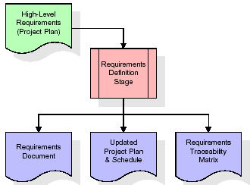
These requirements are fully described in the primary deliverables for this stage: the Requirements Document and the Requirements Traceability Matrix (RTM). The requirements document contains complete descriptions of each requirement, including diagrams and references to external documents as necessary. Note that detailed listings of database tables and fields are not included in the requirements document.
The title of each requirement is also placed into the first version of the RTM, along with the title of each goal from the project plan. The purpose of the RTM is to show that the product components developed during each stage of the software development lifecycle are formally connected to the components developed in prior stages.
In the requirements stage, the RTM consists of a list of high-level requirements, or goals, by title, with a listing of associated requirements for each goal, listed by requirement title. In this hierarchical listing, the RTM shows that each requirement developed during this stage is formally linked to a specific product goal. In this format, each requirement can be traced to a specific product goal, hence the term requirements traceability.
The outputs of the requirements definition stage include the requirements document, the RTM, and an updated project plan.
- Feasibility study is all about identification of problems in a project.
- No. of staff required to handle a project is represented as Team Formation, in this case only modules are individual tasks will be assigned to employees who are working for that project.
- Project Specifications are all about representing of various possible inputs submitting to the server and corresponding outputs along with reports maintained by administrator.
Analysis Stage:
The planning stage establishes a bird's eye view of the intended software product, and uses this to establish the basic project structure, evaluate feasibility and risks associated with the project, and describe appropriate management and technical approaches.
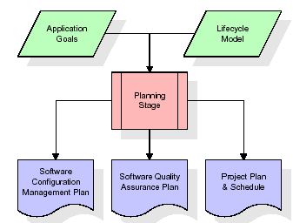
The most critical section of the project plan is a listing of high-level product requirements, also referred to as goals. All of the software product requirements to be developed during the requirements definition stage flow from one or more of these goals. The minimum information for each goal consists of a title and textual description, although additional information and references to external documents may be included. The outputs of the project planning stage are the configuration management plan, the quality assurance plan, and the project plan and schedule, with a detailed listing of scheduled activities for the upcoming Requirements stage, and high level estimates of effort for the out stages.
Designing Stage:
The design stage takes as its initial input the requirements identified in the approved requirements document. For each requirement, a set of one or more design elements will be produced as a result of interviews, workshops, and/or prototype efforts. Design elements describe the desired software features in detail, and generally include functional hierarchy diagrams, screen layout diagrams, tables of business rules, business process diagrams, pseudo code, and a complete entity-relationship diagram with a full data dictionary. These design elements are intended to describe the software in sufficient detail that skilled programmers may develop the software with minimal additional input.

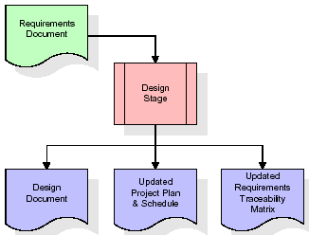
When the design document is finalized and accepted, the RTM is updated to show that each design element is formally associated with a specific requirement. The outputs of the design stage are the design document, an updated RTM, and an updated project plan.
Development (Coding) Stage:
The development stage takes as its primary input the design elements described in the approved design document. For each design element, a set of one or more software artefacts will be produced. Software artefacts include but are not limited to menus, dialogs, and data management forms, data reporting formats, and specialized procedures and functions. Appropriate test cases will be developed for each set of functionally related software artefacts, and an online help system will be developed to guide users in their interactions with the software.
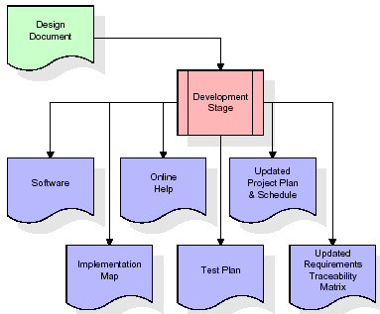

The RTM will be updated to show that each developed artefact is linked to a specific design element, and that each developed artefact has one or more corresponding test case items. At this point, the RTM is in its final configuration. The outputs of the development stage include a fully functional set of software that satisfies the requirements and design elements previously documented, an online help system that describes the operation of the software, an implementation map that identifies the primary code entry points for all major system functions, a test plan that describes the test cases to be used to validate the correctness and completeness of the software, an updated RTM, and an updated project plan.
Integration & Test Stage:
During the integration and test stage, the software artefacts, online help, and test data are migrated from the development environment to a separate test environment. At this point, all test cases are run to verify the correctness and completeness of the software. Successful execution of the test suite confirms a robust and complete migration capability. During this stage, reference data is finalized for production use and production users are identified and linked to their appropriate roles. The final reference data (or links to reference data source files) and production user list are compiled into the Production Initiation Plan.
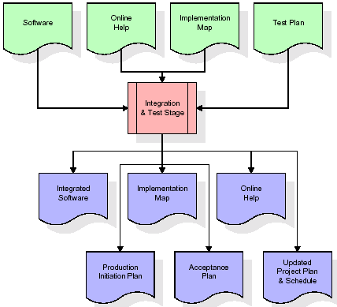
The outputs of the integration and test stage include an integrated set of software, an online help system, an implementation map, a production initiation plan that describes reference data and production users, an acceptance plan which contains the final suite of test cases, and an updated project plan.
- Installation & Acceptance Test:
During the installation and acceptance stage, the software artefacts, online help, and initial production data are loaded onto the production server. At this point, all test cases are run to verify the correctness and completeness of the software. Successful execution of the test suite is a prerequisite to acceptance of the software by the customer.
After customer personnel have verified that the initial production data load is correct and the test suite has been executed with satisfactory results, the customer formally accepts the delivery of the software.
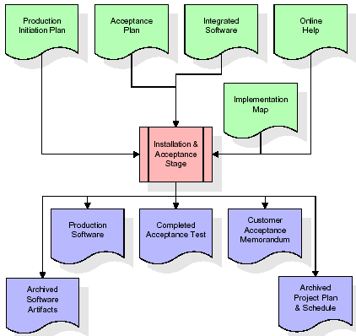
The primary outputs of the installation and acceptance stage include a production application, a completed acceptance test suite, and a memorandum of customer acceptance of the software. Finally, the PDR enters the last of the actual labor data into the project schedule and locks the project as a permanent project record. At this point the PDR "locks" the project by archiving all software items, the implementation map, the source code, and the documentation for future reference.
Maintenance:
Outer rectangle represents maintenance of a project, Maintenance team will start with requirement study, understanding of documentation later employees will be assigned work and they will undergo training on that particular assigned category. For this life cycle there is no end, it will be continued so on like an umbrella (no ending point to umbrella sticks).
3.4. Software Requirement Specification
3.4.1. Overall Description
A Software Requirements Specification (SRS) – a requirements specification for a software system is a complete description of the behavior of a system to be developed. It includes a set of use cases that describe all the interactions the users will have with the software. In addition to use cases, the SRS also contains non-functional requirements. Non-functional requirements are requirements which impose constraints on the design or implementation (such as performance engineering requirements, quality standards, or design constraints).
System requirements specification: A structured collection of information that embodies the requirements of a system. A business analyst, sometimes titled system analyst, is responsible for analyzing the business needs of their clients and stakeholders to help identify business problems and propose solutions. Within the systems development lifecycle domain, the BA typically performs a liaison function between the business side of an enterprise and the information technology department or external service providers. Projects are subject to three sorts of requirements:
- Business requirements describe in business terms what must be delivered or accomplished to provide value.
- Product requirements describe properties of a system or product (which could be one of several ways to accomplish a set of business requirements.)
- Process requirements describe activities performed by the developing organization. For instance, process requirements could specify .Preliminary investigation examine project feasibility, the likelihood the system will be useful to the organization. The main objective of the feasibility study is to test the Technical, Operational and Economical feasibility for adding new modules and debugging old running system. All system is feasible if they are unlimited resources and infinite time. There are aspects in the feasibility study portion of the preliminary investigation:

- ECONOMIC FEASIBILITY
A system can be developed technically and that will be used if installed must still be a good investment for the organization. In the economical feasibility, the development cost in creating the system is evaluated against the ultimate benefit derived from the new systems. Financial benefits must equal or exceed the costs. The system is economically feasible. It does not require any addition hardware or software. Since the interface for this system is developed using the existing resources and technologies available at NIC, There is nominal expenditure and economical feasibility for certain.
- Operational Feasibility
Proposed projects are beneficial only if they can be turned out into information system. That will meet the organization’s operating requirements. Operational feasibility aspects of the project are to be taken as an important part of the project implementation. This system is targeted to be in accordance with the above-mentioned issues. Beforehand, the management issues and user requirements have been taken into consideration. So there is no question of resistance from the users that can undermine the possible application benefits. The well-planned design would ensure the optimal utilization of the computer resources and would help in the improvement of performance status.
- TECHNICAL FEASIBILITY
Earlier no system existed to cater to the needs of ‘Secure Infrastructure Implementation System’. The current system developed is technically feasible. It is a web based user interface for audit workflow at NIC-CSD. Thus it provides an easy access to .the users. The database’s purpose is to create, establish and maintain a workflow among various entities in order to facilitate all concerned users in their various capacities or roles. Permission to the users would be granted based on the roles specified. Therefore, it provides the technical guarantee of accuracy, reliability and security.

3.4.2. External Interface Requirements
User Interface
The user interface of this system is a user friendly python Graphical User Interface.
Hardware Interfaces
The interaction between the user and the console is achieved through python capabilities.
Software Interfaces
The required software is python.
HARDWARE REQUIREMENTS:

Processor - I3(min)
- Speed - 1.1 GHz
- RAM - 4GB(min)
- Hard Disk - 500GB
SOFTWARE REQUIREMENTS:
- Operating System - Windows 10/above
- Programming Language - Python 3.7.0
4. SYSTEM DESIGN
UML Diagram:
The Unified Modelling Language allows the software engineer to express an analysis model using the modelling notation that is governed by a set of syntactic semantic and pragmatic rules.
A UML system is represented using five different views that describe the system from distinctly different perspective. Each view is defined by a set of diagram, which is as follows.
  - User Model View
    - This view represents the system from the users perspective.
    - The analysis representation describes a usage scenario from the end-users perspective.
  - Structural Model view
    - In this model the data and functionality are arrived from inside the system.
    - This model view models the static structures.
- Behavioural Model View
It represents the dynamic of behavioural as parts of the system, depicting the interactions of collection between various structural elements described in the user model and structural model view.
- Implementation Model View
In this the structural and behavioural as parts of the system are represented as they are to be built.
- Environmental Model View
In this the structural and behavioural aspects of the environment in which the system is to be implemented are represented.
Class Diagram:
The class diagram is the main building block of object oriented modeling. It is used both for general conceptual modeling of the systematic of the application, and for detailed modeling translating the models into programming code. Class diagrams can also be used for data modeling. The classes in a class diagram represent both the main objects, interactions in the application and the classes to be programmed. In the diagram, classes are represented with boxes which contain three parts:
- The upper part holds the name of the class
- The middle part contains the attributes of the class
- The bottom part gives the methods or operations the class can take or undertake.
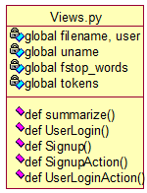
Use case Diagram:
A use case diagram at its simplest is a representation of a user's interaction with the system and depicting the specifications of a use case. A use case diagram can portray the different types of users of a system and the various ways that they interact with the system. This type of diagram is typically used in conjunction with the textual use case and will often be accompanied by other types of diagrams as well.
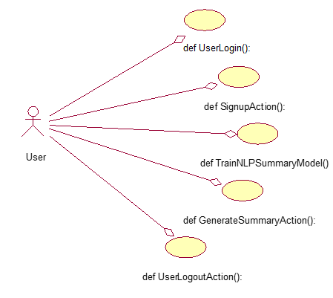
Sequence diagram:
A sequence diagram is a kind of interaction diagram that shows how processes operate with one another and in what order. It is a construct of a Message Sequence Chart. A sequence diagram shows object interactions arranged in time sequence. It depicts the objects and classes involved in the scenario and the sequence of messages exchanged between the objects needed to carry out the functionality of the scenario. Sequence diagrams are typically associated with use case realizations in the Logical View of the system under development. Sequence diagrams are sometimes called event diagrams, event scenarios, and timing diagrams.

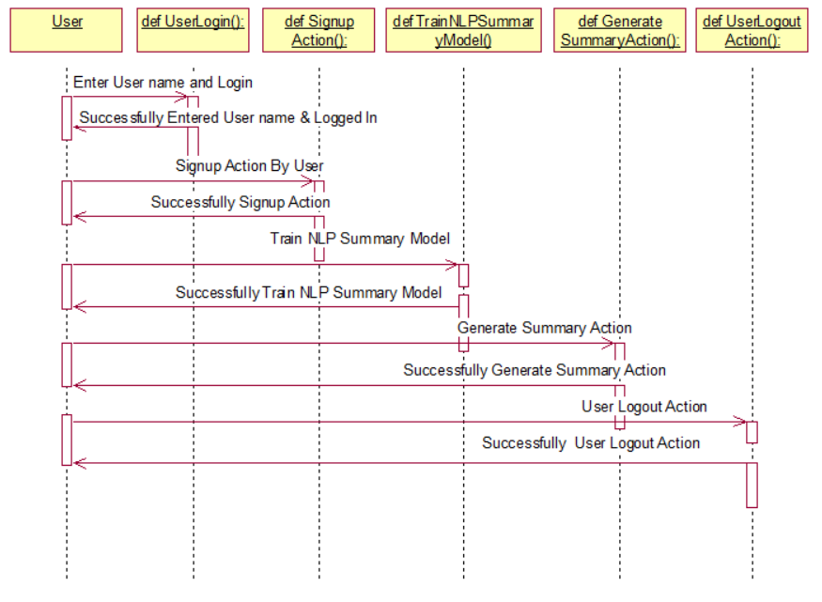
Collaboration diagram:
A collaboration diagram describes interactions among objects in terms of sequenced messages. Collaboration diagrams represent a combination of information taken from class, sequence, and use case diagrams describing both the static structure and dynamic behaviour of a system.

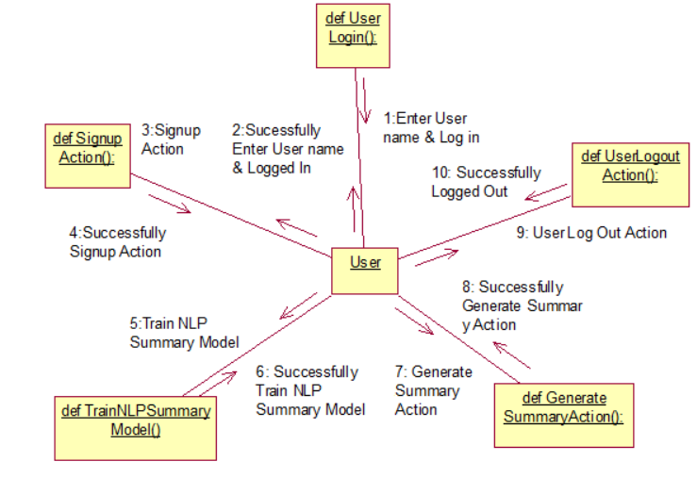
Component Diagram:
In the Unified Modelling Language, a component diagram depicts how components are wired together to form larger components and or software systems. They are used to illustrate the structure of arbitrarily complex systems.
Components are wired together by using an assembly connector to connect the required interface of one component with the provided interface of another component. This illustrates the service consumer - service provider relationship between the two components.
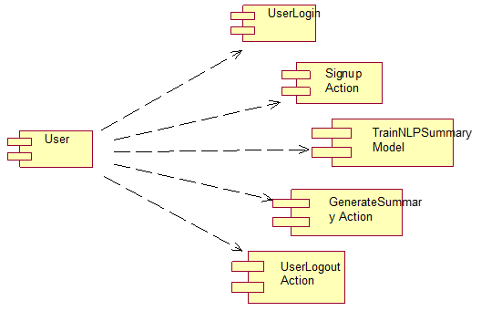

Deployment Diagram:
A deployment diagram in the Unified Modeling Language models the physical deployment of artifacts on nodes. To describe a web site, for example, a deployment diagram would show what hardware components ("nodes") exist (e.g., a web server, an application server, and a database server), what software components ("artifacts") run on each node (e.g., web application, database), and how the different pieces are connected (e.g. JDBC, REST, RMI).
The nodes appear as boxes, and the artifacts allocated to each node appear as rectangles within the boxes. Nodes may have sub nodes, which appear as nested boxes. A single node in a deployment diagram may conceptually represent multiple physical nodes, such as a cluster of database servers.
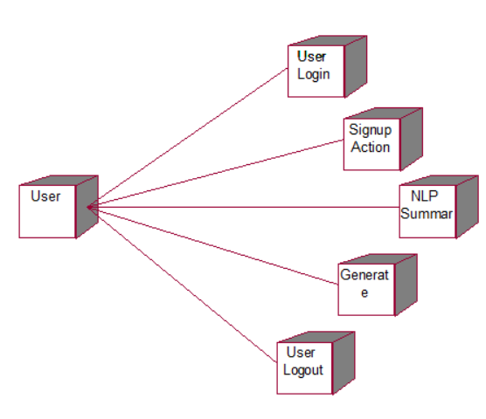

Activity Diagram:
Activity diagram is another important diagram in UML to describe dynamic aspects of the system. It is basically a flow chart to represent the flow form one activity to another
activity. The activity can be described as an operation of the system. So the control flow is drawn from one operation to another. This flow can be sequential, branched or concurrent.

New User Sign up

User Login
Train NLP Summary Model

Generate Summary
User Log Out

Data Flow Diagram:
Data flow diagrams illustrate how data is processed by a system in terms of inputs and outputs. Data flow diagrams can be used to provide a clear representation of any business function. The technique starts with an overall picture of the business and continues by analyzing each of the functional areas of interest. This analysis can be carried out in precisely the level of detail required. The technique exploits a method called top-down expansion to conduct the analysis in a targeted way.
As the name suggests, Data Flow Diagram (DFD) is an illustration that explicates the passage of information in a process. A DFD can be easily drawn using simple symbols. Additionally, complicated processes can be easily automated by creating DFDs using easy-to-use, free downloadable diagramming tools. A DFD is a model for constructing and analyzing information processes. DFD illustrates the flow of information in a process depending upon the inputs and outputs. A DFD can also be referred to as a Process Model. A DFD demonstrates business or technical process with the support of the outside data saved, plus the data flowing from the process to another and the end results.
User

1. New User Sign up 2. Successfully New User Sign up
3. User Login 4. Successfully User Login
5. Train NLP Summary Model 6. Successfully Train NLP Model
7. Generate Summary 8. Successfully Generate Summary
9. User Log Out 10. Successfully User Log Out
System

5. IMPLEMETATION
5.1 PYTHON
* One of the most popular languages is Python. Guido van Rossum released this language in 1991. Python is available on the Mac, Windows, and Raspberry Pi operating systems. The syntax of Python is simple and identical to that of English. When compared to Python, it was seen that the other language requires a few extra lines.
*It is an interpreter-based language because code may be run line by line after it has been written. This implies that rapid prototyping is possible across all platforms. Python is a big language with a free, binary-distributed interpreter standard library.
* It is inferior to maintenance that is conducted and is straightforward to learn. It is an object-oriented, interpreted programming language. It supports several different programming paradigms in addition to object-oriented programming, including functional and procedural programming.
* It supports several different programming paradigms in addition to object-oriented programming, including practical and procedural programming. Python is mighty while maintaining a relatively straightforward syntax. Classes, highly dynamic data types, modules, and exceptions are covered. Python can also be utilised by programmes that require programmable interfaces as an external language.
Here are some key features and characteristics of Python:
- Readability: Python emphasizes code readability with its clean and intuitive syntax. It uses indentation and whitespace to structure code blocks, making it easy to understand and maintain.
- Easy to Learn: Python's simplicity and readability make it an excellent choice for beginners. Its straightforward syntax and extensive documentation make it accessible for newcomers to programming.
- Interpreted Language: Python is an interpreted language, meaning that it doesn't need to be compiled before running. The Python interpreter reads and executes the code directly, making the development process faster and more interactive.
- Cross-platform Compatibility: Python is available for major operating systems like Windows, macOS, and Linux. This cross-platform compatibility allows developers to write code once and run it on different platforms without modifications.
- Large Standard Library: Python comes with a vast standard library that provides ready-to-use modules and functions for various tasks. It covers areas such as file I/O, networking, regular expressions, databases, and more, saving developers time and effort.
- Extensible and Modular: Python supports modular programming, enabling developers to organize code into reusable modules and packages. Additionally, Python allows integrating modules written in other languages, such as C or C++, providing flexibility and performance optimizations.
- Wide Range of Libraries and Frameworks: Python has a vibrant ecosystem with numerous third-party libraries and frameworks. These libraries, such as NumPy, pandas, TensorFlow, and Django, extend Python's capabilities for specific domains, making it a powerful tool for diverse applications.
- Object-Oriented: Python supports object-oriented programming (OOP) principles, allowing developers to create and work with classes and objects. OOP provides a structured approach to code organization, promoting code reuse and modularity.
- Dynamic Typing: Python is dynamically typed, meaning variable types are determined at runtime. Developers do not need to declare variable types explicitly, which enhances flexibility and simplifies code writing.
5.2 Installation
To install Python on your computer, follow these basic steps:
- Step 1: Visit the Python website Go to the official Python website at https://www.python.org/.
- Step 2: Select the operating system Choose the appropriate installer for your operating system. Python supports Windows, macOS, and various Linux distributions. Make sure to select the correct version that matches your operating system.
- Step 3: Check which version of Python is installed; if the 3.7.0 version is not there, uninstall it through the control panel and
- Step 4: Install Python 3.7.0 using Cmd.
- Step 5: Install the all libraries that required to run the project
- Step 6: Run
5.3 Python Features:
- Easy: Because Python is a more accessible and straightforward language, Python programming is easier to learn.
- Interpreted language: Python is an interpreted language, therefore it can be used to examine the code line by line and provide results.
- Open Source: Python is a free online programming language since it is open-source.
- Portable: Python is portable because the same code may be used on several computer standard
- libraries: Python offers a sizable library that we may utilize to create applications quickly.
- GUI: It stands for GUI (Graphical User Interface)
- Dynamical typed: Python is a dynamically typed language, therefore the type of the value will be determined at runtime.
5.4 Python GUI (Tkinter)
- Python provides a wide range of options for GUI development (Graphical User Interfaces).
- Tkinter, the most widely used GUI technique, is used for all of them.
- The Tk GUI toolkit offered by Python is used with the conventional Python interface.
- Tkinter is the easiest and quickest way to write Python GUI programs.
- Using Tkinter, creating a GUI is simple.
- A part of Python's built-in library is Tkinter. The GUI programs were created.
- Python and Tkinter together give a straightforward and quick way. The Tk GUI toolkit's object-oriented user interface is called Tkinter.

Making a GUI application is easy using Tkinter. Following are the steps:
1) Install the Tkinter module in place.
2) The GUI applicatioMakeske the primary window
3) Include one or more of the widgets mentioned above in the GUI application.
4) Set up the main event loop such that it reacts to each user-initiated event.
Although Tkinter is the only GUI framework included in the Python standard library, Python includes a GUI framework. The default library for Python is called Tkinter. Tk is a scripting language often used in designing, testing, and developing GUIs. Tk is a free, open-source widget toolkit that may be used to build GUI applications in a wide range of computer languages.
5.5 Python IDLE
- Python IDLE offers a full-fledged file editor, which gives you the ability to write and execute Python programs from within this program. The built-in file editor also includes several features, like code completion and automatic indentation, that will speed up your coding workflow.
- Guido Van Rossum named Python after the British comedy group Monty Python while the name IDLE was chosen to pay tribute to Eric Idle, who was one of the Monty Python's founding members. IDLE comes bundled with the default implementation of the Python language since the 01.5. 2b1 release
- IDLE is used to execute statements similar to Python Shell. IDLE is used to create, modify, and execute Python code. IDLE provides a fully-featured text editor to write Python scripts and provides features like syntax highlighting, auto-completion, and smart indent.
- IDLE has two modes: interactive and script. We wrote our first program, “Hello, World!” in interactive mode. Interactive mode immediately returns the results of commands you enter into the shell. In script mode, you will write a script and then run it.
- The IDE Python IDLE is a good place to start as it helps you become familiar with the way Python works and understand its syntax. This IDE is good to start programming in Python due to its great debugger, but once you are fluent and start developing projects it is necessary to jump to another, more complete IDE.
- Python IDLE (Integrated Development and Learning Environment) is an interactive development environment included with the Python programming language. It provides a convenient way to write, execute, and debug Python code.
When you install Python, IDLE is typically installed along with it. To open IDLE, you can follow these steps:
- Open the command prompt (Windows) or terminal (macOS/Linux).
- Type "idle" and press Enter. Alternatively, you can specify the version with "idle3" or "idle2" for Python 3 or Python 2, respectively.
- Once IDLE is launched, you will see the Python shell, which is an interactive environment where you can type and execute Python code directly.
Here are some features and functionalities provided by Python IDLE:
- Editor: IDLE includes a text editor where you can write your Python code. It offers syntax highlighting, automatic indentation, and code completion to enhance your coding experience.
- Interactive Shell: The Python shell in IDLE allows you to execute Python code interactively. You can type commands, statements, or function calls directly in the shell, and Python will execute them immediately.
- Debugging: IDLE provides basic debugging capabilities to help you find and fix errors in your code. You can set breakpoints, step through code, inspect variables, and track the program's execution.
- Python Help: IDLE provides access to the Python documentation and built-in help. You can access the help menu to find information about Python modules, functions, classes, and more.
- Script Execution: In addition to the interactive shell, IDLE allows you to run Python scripts stored in files. You can write your code in the editor and execute it as a script to see the output or interact with the program.
- Customization: IDLE can be customized to suit your preferences. You can modify settings related to syntax highlighting, indentation, fonts, and more.
- Python IDLE serves as a beginner-friendly development environment and learning tool. It is suitable for writing small scripts, testing code snippets, experimenting with Python features, and learning the language's basics. However, for more advanced development projects, you may consider using other code editors or integrated development environments (IDEs) that provide additional features and better project management capabilities.
5.6 Libraries
In Python, libraries (also referred to as modules or packages) are collections of pre-written code that provide additional functionality and tools to extend the capabilities of the Python language. Libraries contain reusable code that developers can leverage to perform specific tasks without having to write everything from scratch.
Python libraries are designed to solve common problems, such as handling data, performing mathematical operations, interacting with databases, working with files, implementing networking protocols, creating graphical user interfaces (GUIs), and much more. They provide ready-to-use functions, classes, and methods that simplify complex operations and save development time.
Libraries in Python offer various advantages:
- Code Reusability:
- Efficiency:
- Collaboration
- Domain-Specific Functionality
- To use a Python library, you need to install it first.
There are some libraries following:
- Pandas:
Pandas are a Python computer language library for data analysis and manipulation. It offers a specific operation and data format for handling time series and numerical tables. It differs significantly from the release3-clause of the BSD license. It is a well-liked open-source of opinion that is utilized in machine learning and data analysis.
Pandas are a Python package providing fast, flexible, and expressive data structures designed to make working with “relational” or “labeled” data both easy and intuitive. It aims to be the fundamental high-level building block for doing practical, real-world data analysis in Python. Pandas are a Python library used for working with data sets.
- It has functions for analysing, cleaning, exploring, and manipulating data.
- The name "Pandas" has a reference to both "Panel Data", and "Python Data Analysis" and was created by Wes McKinney in 2008.
- Pandas allow us to analyse big data and make conclusions based on statistical theories.
- Pandas can clean messy data sets, and make them readable and relevant.
Relevant data is very important in data science. Pandas are a Python library for data analysis. Started by Wes McKinney in 2008 out of a need for a powerful and flexible quantitative analysis tool, pandas have grown into one of the most popular Python libraries. It has an extremely active community of contributors. The name is derived from the term "panel data", an econometrics term for data sets that include observations over multiple time periods for the same individuals. Its name is a play on the phrase "Python data analysis" itself.
- NumPy:
The NumPy Python library for multi-dimensional, big-scale matrices adds a huge number of high-level mathematical functions. It is possible to modify NumPy by utilizing a Python library. Along with line, algebra, and the Fourier transform operations, it also contains several matrices-related functions.
NumPy can be used to perform a wide variety of mathematical operations on arrays. It adds powerful data structures to Python that guarantee efficient calculations with arrays and matrices and it supplies an enormous library of high-level mathematical functions that operate on these arrays and matrices.
- NumPy is a Python library used for working with arrays.
- It also has functions for working in domain of linear algebra, Fourier transform, and matrices.
- NumPy was created in 2005 by Travis Oliphant. It is an open source project and you can use it freely.
- NumPy stands for Numerical Python.
- In Python we have lists that serve the purpose of arrays, but they are slow to process.
- NumPy aims to provide an array object that is up to 50x faster than traditional Python lists.
- The array object in NumPy is called ndarray, it provides a lot of supporting functions that make working with ndarray very easy.
- Arrays are very frequently used in data science, where speed and resources are very important.

- Matplotlib:
It is a multi-platform, array-based data visualization framework built to interact with the whole SciPy stack. MATLAB is proposed as an open-source alternative. Matplotlib is a Python extension and a cross-platform toolkit for graphical plotting and visualization.
Matplotlib is a popular Python library for creating static, animated, and interactive visualizations. It provides a flexible and comprehensive set of tools for generating plots, charts, histograms, scatter plots, and more. Matplotlib is widely used in various fields, including data analysis, scientific research, and data visualization.
Here are some key features and functionalities of the Matplotlib library:
- Plotting Functions
- Customization Options
- Multiple Interfaces
- Integration with NumPy and pandas
- Subplots and Figures:
- Saving and Exporting

- Scikit-learn:
The most stable and practical machine learning library for Python is scikit-learn. Regression, dimensionality reduction, classification, and clustering are just a few of the helpful tools it provides through the Python interface for statistical modelling and machine learning. It is an essential part of the Python machine learning toolbox used by JP Morgan. It is frequently used in various machine learning applications, including classification and predictive analysis.
Scikit-learn (also referred to as sklearn) is a widely used open-source machine learning library for Python. It provides a comprehensive set of tools and algorithms for various machine learning tasks, including classification, regression, clustering, dimensionality reduction, model selection, and pre-processing.
Here are some key features and functionalities of the Scikit-learn library:
- Easy-to-Use Interface:
- Broad Range of Algorithms:
- Data Pre-processing and Feature Engineering:
- Model Evaluation and Validation:
- Integration with NumPy and pandas:
- Robust Documentation and Community Support:

- Keras:
* Google's Keras is a cutting-edge deep learning API for creating neural networks. It is created in Python and is designed to simplify the development of neural networks. Additionally, it enables the use of various neural networks for computation. Deep learning models are developed and tested using the free and open-source Python software known as Keras.
Keras is a high-level deep learning library for Python. It is designed to provide a user-friendly and intuitive interface for building and training deep learning models. Keras acts as a front-end API, allowing developers to define and configure neural networks while leveraging the computational backend engines, such as Tensor Flow or Theano.
Here are some key features and functionalities of the Keras library:
- User-Friendly API
- Multi-backend Support
- Wide Range of Neural Network Architectures
- Pre-trained Models and Transfer Learning:
- Easy Model Training and Evaluation:
- GPU Support:
- h5py:
* The h5py Python module offers an interface for the binary HDF5 data format. Thanks to p5py, the top can quickly halt the vast amount of numerical data and alter it using the NumPy library. It employs common syntax for Python, NumPy, and dictionary arrays.
h5py is a Python library that provides a simple and efficient interface for working with datasets and files in the Hierarchical Data Format 5 (HDF5) format. HDF5 is a versatile data format commonly used for storing and managing large volumes of numerical data.
Here are some key features and functionalities of the h5py library:
  - HDF5 File Access
  - Dataset Handling:
  - Group Organization:
  - Attributes:
  - Compatibility with NumPy
  - Performance

- Tensor flow
TensorFlow is a Python library for fast numerical computing created and released by Google. It is a foundation library that can be used to create Deep Learning models directly or by using wrapper libraries that simplify the process built on top of TensorFlow. TensorFlow is an end-to-end open source platform for machine learning. TensorFlow is a rich system for managing all aspects of a machine learning system; however, this class focuses on using a particular TensorFlow API to develop and train machine learning models.
TensorFlow is a popular open-source library for machine learning and deep learning. It provides a comprehensive set of tools, APIs, and computational resources for building and training various types of machine learning models, especially neural networks.
Here are some key features and functionalities of TensorFlow:
- Neural Network Framework:
- Computational Graphs
- Automatic Differentiation
- GPU and TPU Support
- Distributed Computing
- Deployment Capabilities

- Tkinter
Tkinter is an acronym for "Tk interface". Tk was developed as a GUI extension for the Tcl scripting language by John Ousterhout. The first release was in 1991. Tkinter is the de facto way in Python to create Graphical User interfaces (GUIs) and is included in all standard Python Distributions. In fact, it's the only framework built into the Python standard library.
Tkinter is a standard Python library used for creating graphical user interfaces (GUIs). It provides a set of modules and classes that allow you to develop interactive and visually appealing desktop applications.
Here are some key features and functionalities of Tkinter:
- Cross-Platform Compatibility
- Simple and Easy-to-Use
- Widgets and Layout Management
- Event-Driven Programming
- Customization and Styling
- Integration with Other Libraries

- NLTK
NLTK is a toolkit build for working with NLP in Python. It provides us various text processing libraries with a lot of test datasets. A variety of tasks can be performed using NLTK such as tokenizing, parse tree visualization, etc NLTK (Natural Language Toolkit) is the go-to API for NLP (Natural Language Processing) with Python. It is a really powerful tool to pre-process text data for further analysis like with ML models for instance. It helps convert text into numbers, which the model can then easily work with.
NLTK (Natural Language Toolkit) is a Python library widely used for working with human language data and implementing natural language processing (NLP) tasks. It provides a set of tools, corpora, and resources for tasks such as tokenization, stemming, tagging, parsing, sentiment analysis, and more.
Here are some key features and functionalities of NLTK:
- Text Processing
- Part-of-Speech Tagging
- Named Entity Recognition
- Chunking and Parsing
- Sentiment Analysis:
- WordNet Integration:

- Scipy
SciPy is a collection of mathematical algorithms and convenience functions built on the NumPy extension of Python. It adds significant power to the interactive Python session by providing the user with high-level commands and classes for manipulating and visualizing data.
SciPy is a powerful scientific computing library for Python that provides a wide range of mathematical algorithms and functions. It builds upon NumPy, another fundamental library for numerical computing, and extends its capabilities by adding additional tools for scientific and technical computing tasks.
Here are some key features and functionalities of SciPy:
- Numerical Integration:
- Optimization and Root Finding
- Linear Algebra
- Signal and Image Processing
- Statistics
5.2 Sample Code:
Views.py:
from django.shortcuts import render
from django.template import RequestContext
from django.contrib import messages
import pymysql
from django.http import HttpResponse
import json
from string import punctuation
from nltk.corpus import stopwords
import nltk
from nltk import tokenize
from heapq import nlargest
from rouge_score import rouge_scorer
import matplotlib.pyplot as plt
from transformers import pipeline
import pandas as pd
import io
import base64

global uname
stop_words = set(stopwords.words('english'))

#function to summarize essay
def summarize(essay, threshold):
word_frequencies = {}
tokens = essay.split(" ")
for word in tokens:
if word.lower() not in stop_words:
if word not in word_frequencies.keys():
word_frequencies[word] = 1
else:
word_frequencies[word] += 1
max_frequency = max(word_frequencies.values())
for word in word_frequencies.keys():
word_frequencies[word] = word_frequencies[word]/max_frequency
sentence_tokens = tokenize.sent_tokenize(essay)
sentence_scores = {}
for sent in sentence_tokens:
words = sent.split(" ")
for word in words:
if word.lower() in word_frequencies.keys():
if sent not in sentence_scores.keys():
sentence_scores[sent] = word_frequencies[word.lower()]
else:
sentence_scores[sent] += word_frequencies[word.lower()]
select_length = int(len(sentence_tokens)*threshold)
summary = nlargest(select_length, sentence_scores, key = sentence_scores.get)
final_summary = [word for word in summary]
summary = ' '.join(final_summary)
return summary

file = open('Dataset/tldrlegal_v1.json')
data = json.load(file)
file.close()
scorer = rouge_scorer.RougeScorer(['rouge1', 'rougeL'], use_stemmer=True) #calculate rouge scrore between test and predicted

precision = 0
recall = 0
fscore = 0
pre = []
rec = []
fsc = []
j = 0
original_data = None
original_sum = None
for key, value in data.items():
text = value['original_text']
summary = value['reference_summary']
if j == 2:
original_data = text
original_sum = summary
nlp_summary = summarize(text, 0.95)
scores = scorer.score(summary, nlp_summary)
score = scores['rouge1']
#print(score)
p = score[0]
r = score[1]
f = score[2]
if p > precision:
precision = p
if r > recall:
recall = r
if f > fscore:
fscore = f
j += 1
pre.append(precision)
rec.append(recall)
fsc.append(fscore)
transformer = pipeline("summarization")
predict = transformer(original_data)[0]['summary_text']
scores = scorer.score(original_sum, predict)
score = scores['rouge1']
p = score[0]
r = score[1]
f = score[2]
pre.append(p)
rec.append(r)
fsc.append(f)

def TrainNLP(request):
if request.method == 'GET':
global precision, recall, fscore
output = ''
output+='<table border=1 align=center width=100%><tr><th><font size="" color="black">Algorithm Name</th><th><font size="" color="black">Precision</th>'
output+='<th><font size="" color="black">Recall</th><th><font size="" color="black">FMEASURE</th></tr>'
algorithms = ['NLP Summary', 'Transformer Summary']
output+='<tr><td><font size="" color="black">'+algorithms[0]+'</td><td><font size="" color="black">'+str(pre[0])+'</td><td><font size="" color="black">'+str(rec[0])+'</td><td><font size="" color="black">'+str(fsc[0])+'</td></tr>'
output+='<tr><td><font size="" color="black">'+algorithms[1]+'</td><td><font size="" color="black">'+str(pre[1])+'</td><td><font size="" color="black">'+str(rec[1])+'</td><td><font size="" color="black">'+str(fsc[1])+'</td></tr>'
output+= "</table></br></br>"
df = pd.DataFrame([['NLP Summary','Precision',pre[0]],['NLP Summary','Recall',rec[0]],['NLP Summary','F1 Score',fsc[0]],
['Transformer Summary','Precision',pre[1]],['Transformer Summary','Recall',rec[1]],['Transformer Summary','F1 Score',fsc[1]],
],columns=['Algorithms','Metrics','Value'])
df.pivot_table(index="Algorithms", columns="Metrics", values="Value").plot(kind='bar', figsize=(5, 3))
plt.title("All Algorithms Performance Graph")
buf = io.BytesIO()
plt.savefig(buf, format='png', bbox_inches='tight')
plt.close()
img_b64 = base64.b64encode(buf.getvalue()).decode()
context= {'data':output, 'img': img_b64}
return render(request, 'UserScreen.html', context)

def UserLogin(request):
if request.method == 'GET':
return render(request, 'UserLogin.html', {})

def index(request):
if request.method == 'GET':
return render(request, 'index.html', {})

def Signup(request):
if request.method == 'GET':
return render(request, 'Signup.html', {})

def Aboutus(request):
if request.method == 'GET':
return render(request, 'Aboutus.html', {})

def SignupAction(request):
if request.method == 'POST':
username = request.POST.get('t1', False)
password = request.POST.get('t2', False)
contact = request.POST.get('t3', False)
email = request.POST.get('t4', False)
address = request.POST.get('t5', False)

status = 'none'
con = pymysql.connect(host='127.0.0.1',port = 3306,user = 'root', password = 'root', database = 'summary',charset='utf8')
with con:
cur = con.cursor()
cur.execute("select username from signup where username = '"+username+"'")
rows = cur.fetchall()
for row in rows:
if row[0] == email:
status = 'Given Username already exists'
break
if status == 'none':
db_connection = pymysql.connect(host='127.0.0.1',port = 3306,user = 'root', password = 'root', database = 'summary',charset='utf8')
db_cursor = db_connection.cursor()
student_sql_query = "INSERT INTO signup(username,password,contact_no,email_id,address) VALUES('"+username+"','"+password+"','"+contact+"','"+email+"','"+address+"')"
db_cursor.execute(student_sql_query)
db_connection.commit()
print(db_cursor.rowcount, "Record Inserted")
if db_cursor.rowcount == 1:
status = 'Signup Process Completed'
context= {'data':status}
return render(request, 'Signup.html', context)

def UserLoginAction(request):
if request.method == 'POST':
global uname
option = 0
username = request.POST.get('username', False)
password = request.POST.get('password', False)
con = pymysql.connect(host='127.0.0.1',port = 3306,user = 'root', password = 'root', database = 'summary',charset='utf8')
with con:
cur = con.cursor()
cur.execute("select * FROM signup")
rows = cur.fetchall()
for row in rows:
if row[0] == username and row[1] == password:
uname = username
option = 1
break
if option == 1:
output = "Welcome "+uname
context= {'data':output}
return render(request, 'UserScreen.html', context)
else:
context= {'data':'Invalid login details'}
return render(request, 'UserLogin.html', context)

def GenerateSummary(request):
if request.method == 'GET':
return render(request, 'GenerateSummary.html', {})

def GenerateSummaryAction(request):
if request.method == 'POST':
global uname
textdata = request.POST.get('t1', False)
summary = summarize(textdata, 0.3)
'''
output = '<table align="center" width="80">'
output += '<tr><td><font size="3" color="black">Input&nbsp;Text</b></td><td><textarea name="t1" rows="15" cols="80">'+textdata+'</textarea></td></tr>'
output += '<br/><br/><tr><td><font size="3" color="black">Generated&nbsp;Summary</b></td><td><textarea name="t2" rows="10" cols="80">'+summary+'</textarea></td></tr>'
output += "</table></br></br></br>"
'''

output = '<p align="justify"><font size="3" style="font-family: Comic Sans MS" color="black">Input Text = '+textdata+'</p><br/>'
output += '<p align="justify"><font size="3" style="font-family: Comic Sans MS" color="black">Generated Summary = '+summary+'</p><br/><br/><br/><br/><br/>'
context= {'data':output}
return render(request, 'UserScreen.html', context)

6. TESTING
Implementation and Testing:
Implementation is one of the most important tasks in project is the phase in which one has to be cautions because all the efforts undertaken during the project will be very interactive. Implementation is the most crucial stage in achieving successful system and giving the users confidence that the new system is workable and effective. Each program is tested individually at the time of development using the sample data and has verified that these programs link together in the way specified in the program specification. The computer system and its environment are tested to the satisfaction of the user.

Implementation

The implementation phase is less creative than system design. It is primarily concerned with user training, and file conversion. The system may be requiring extensive user training. The initial parameters of the system should be modifies as a result of a programming. A simple operating procedure is provided so that the user can understand the different functions clearly and quickly. The different reports can be obtained either on the inkjet or dot matrix printer, which is available at the disposal of the user. The proposed system is very easy to implement. In general implementation is used to mean the process of converting a new or revised system design into an operational one.

Testing
Testing is the process where the test data is prepared and is used for testing the modules individually and later the validation given for the fields. Then the system testing takes place which makes sure that all components of the system property functions as a unit. The test data should be chosen such that it passed through all possible condition. Actually testing is the state of implementation which aimed at ensuring that the system works accurately and efficiently before the actual operation commence. The following is the description of the testing strategies, which were carried out during the testing period.

System Testing
Testing has become an integral part of any system or project especially in the field of information technology. The importance of testing is a method of justifying, if one is ready to move further, be it to be check if one is capable to with stand the rigors of a particular situation cannot be underplayed and that is why testing before development is so critical. When the software is developed before it is given to user to use the software must be tested whether it is solving the purpose for which it is developed. This testing involves various types through which one can ensure the software is reliable. The program was tested logically and pattern of execution of the program for a set of data are repeated. Thus the code was exhaustively checked for all possible correct data and the outcomes were also checked.

Module Testing
To locate errors, each module is tested individually. This enables us to detect error and correct it without affecting any other modules. Whenever the program is not satisfying the required function, it must be corrected to get the required result. Thus all the modules are individually tested from bottom up starting with the smallest and lowest modules and proceeding to the next level. Each module in the system is tested separately. For example the job classification module is tested separately. This module is tested with different job and its approximate execution time and the result of the test is compared with the results that are prepared manually. The comparison shows that the results proposed system works efficiently than the existing system. Each module in the system is tested separately. In this system the resource classification and job scheduling modules are tested separately and their corresponding results are obtained which reduces the process waiting time.
Integration Testing
After the module testing, the integration testing is applied. When linking the modules there may be chance for errors to occur, these errors are corrected by using this testing. In this system all modules are connected and tested. The testing results are very correct. Thus the mapping of jobs with resources is done correctly by the system.
Acceptance Testing
When that user fined no major problems with its accuracy, the system passers through a final acceptance test. This test confirms that the system needs the original goals, objectives and requirements established during analysis without actual execution which elimination wastage of time and money acceptance tests on the shoulders of users and management, it is finally acceptable and ready for the operation
Test Case Id | Test Case Name | Test Case Desc. | Test Steps |  |  | Test Case Status | Test Priority
 |  |  | Step | Expected | Actual
01 | New User Sign up | Test whether New User Signed up not into the system | If the User may not signed up | We cannot do further operations | Once user signed up done we will do further operations | High | High
02 | User Login | Test whether the User Login Process Successfully or not | If the User Login not Run Successfully | We cannot do further operations | we will do further  operations | High | High
03 | Train NLP Summary Model | Test whether Train NLP Summary Model  Successfully or not | If the Train NLP Summary Model may not Successfully | We cannot do further operations | we will do further  operations | High | High
04 | Generate Summary | Test whether Generate Summary Run Successfully or not | If the  Generate Summary not Run Successfully | We cannot do further operations | we will do further  operations | High | High
05 | User Logout Action | Test whether User Logout Action Run Successfully or not | If the  User Logout Action may not Run Successfully | We cannot do further operations | we will do further  operations | High | High

7.SCREENSHOTS:
To run project install MYSQL database and then copy content from DB.txt and paste in MYSQL console to create database.
Install python 3.7 and then install all packages given in requirement.txt file and then double click on run.bat file to get below page
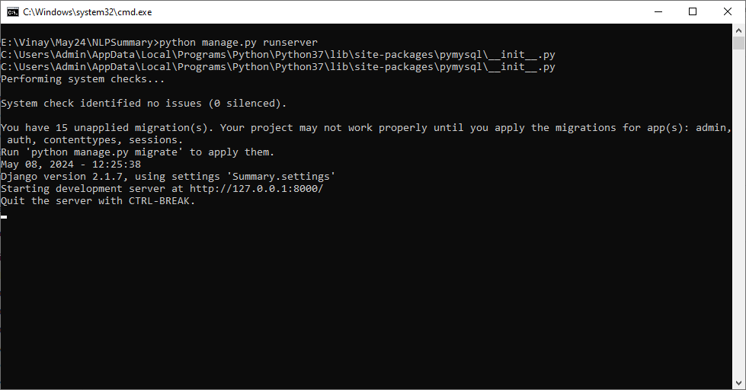
In above screen python server started and now open browser and enter URL as http://127.0.0.1:8000/index.html and press enter key to get below page
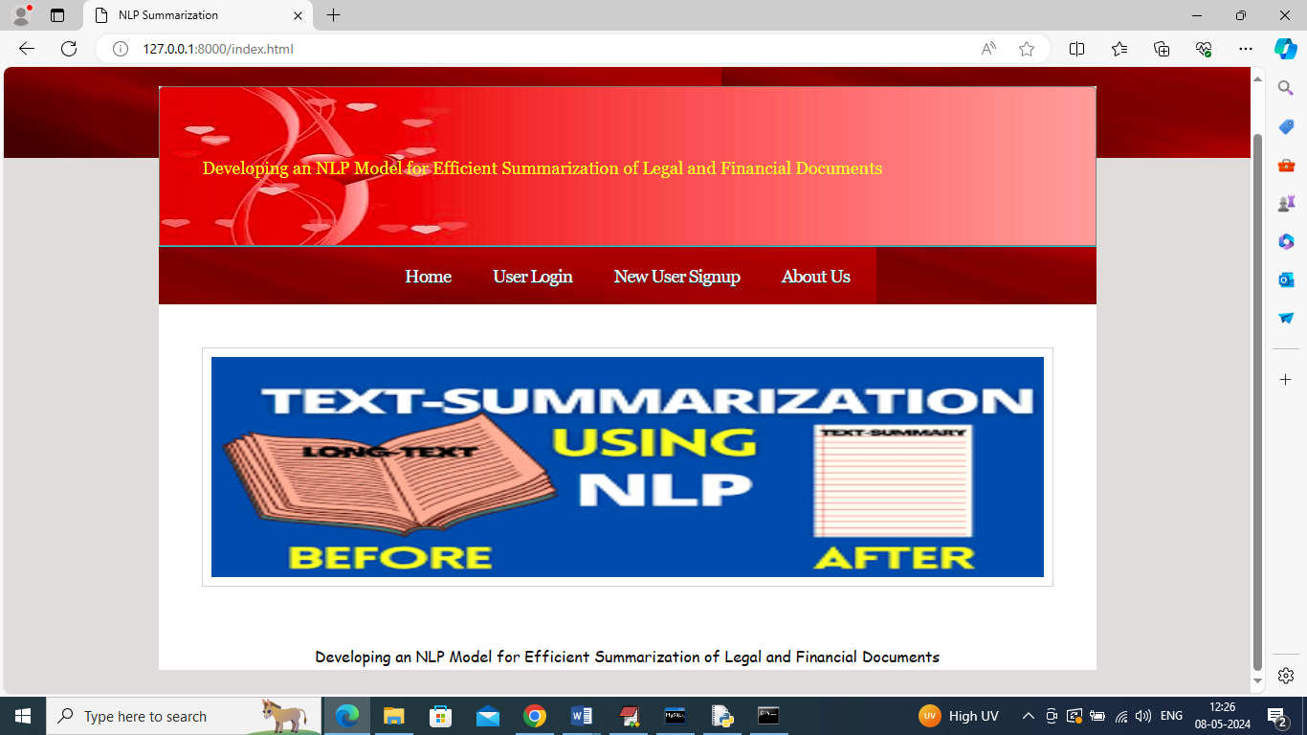
In above screen click on ‘New User Sign up’ link to get below page
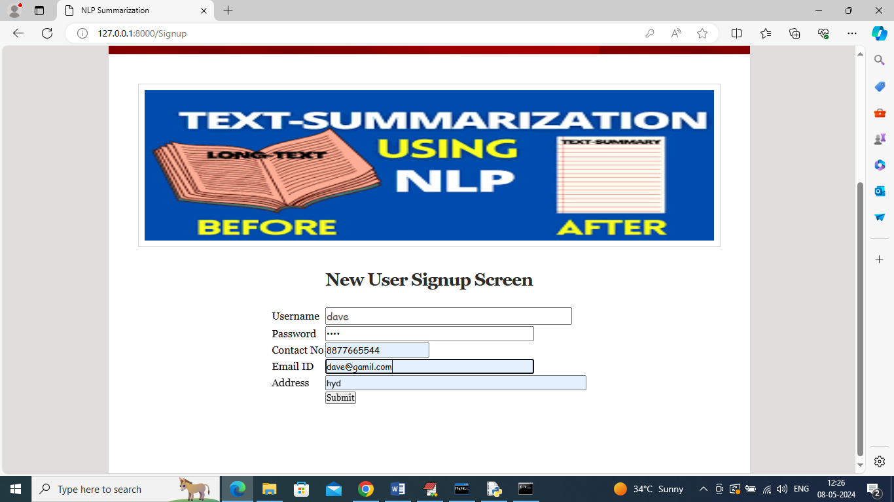
In above screen user is entering sign up details and then press button to get below page
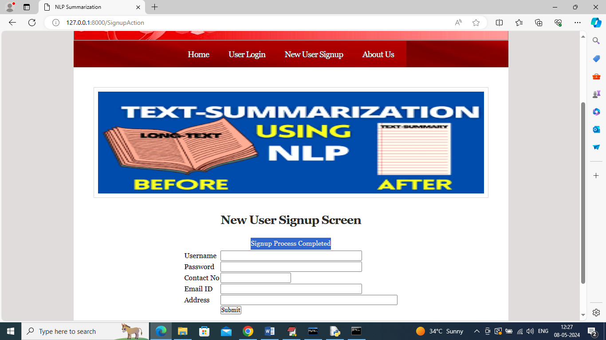
In above screen sign up task completed and now click on ‘User Login’ link to get below page
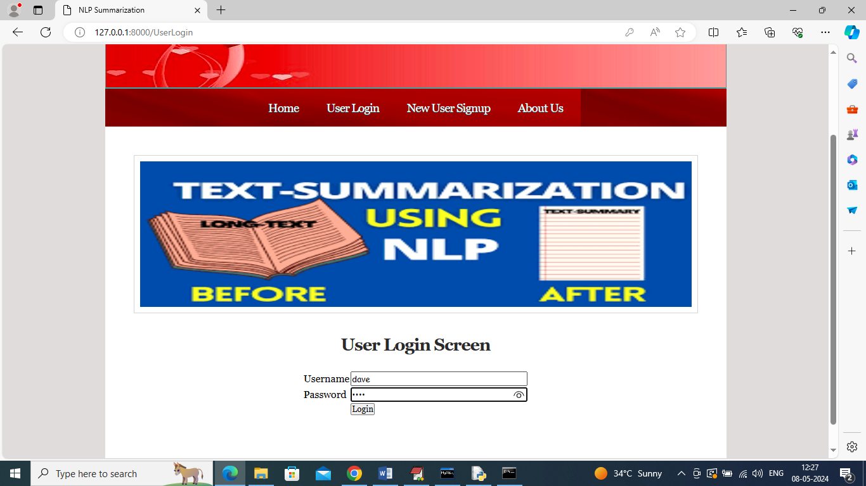
In above screen user is login and after login will get below page
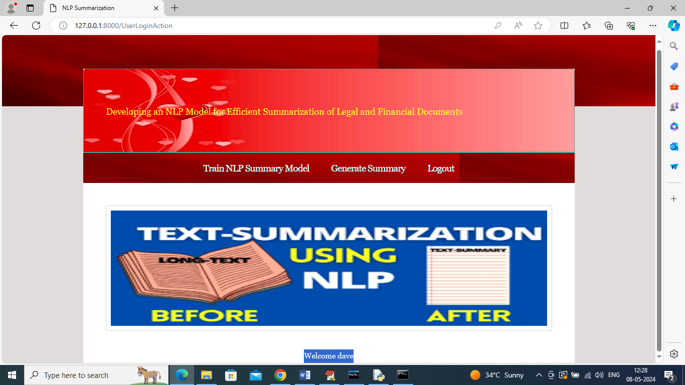
In above screen user can click on ‘Train NLP Summary Model’ link to train NLP algorithm on LEGAL dataset and get below output
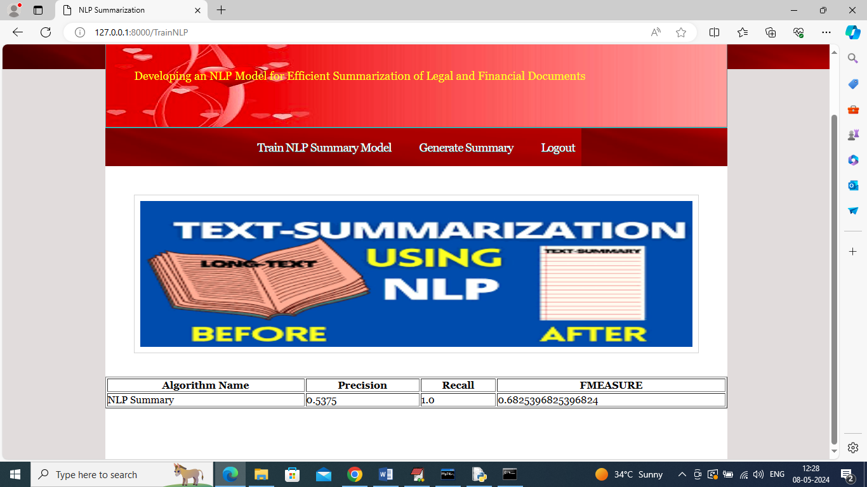
In above screen can see performance metrics of NLP on summary generation and got recall as 100%. Now click on “Generate Summary” link to get below page
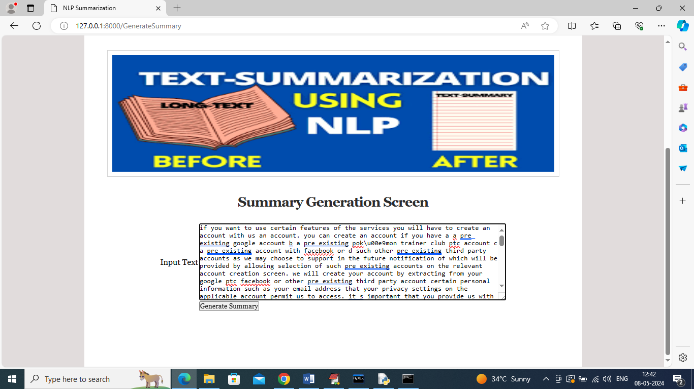
In above screen you can enter some text and then click on ‘Generate Summary’ button to get below summary output
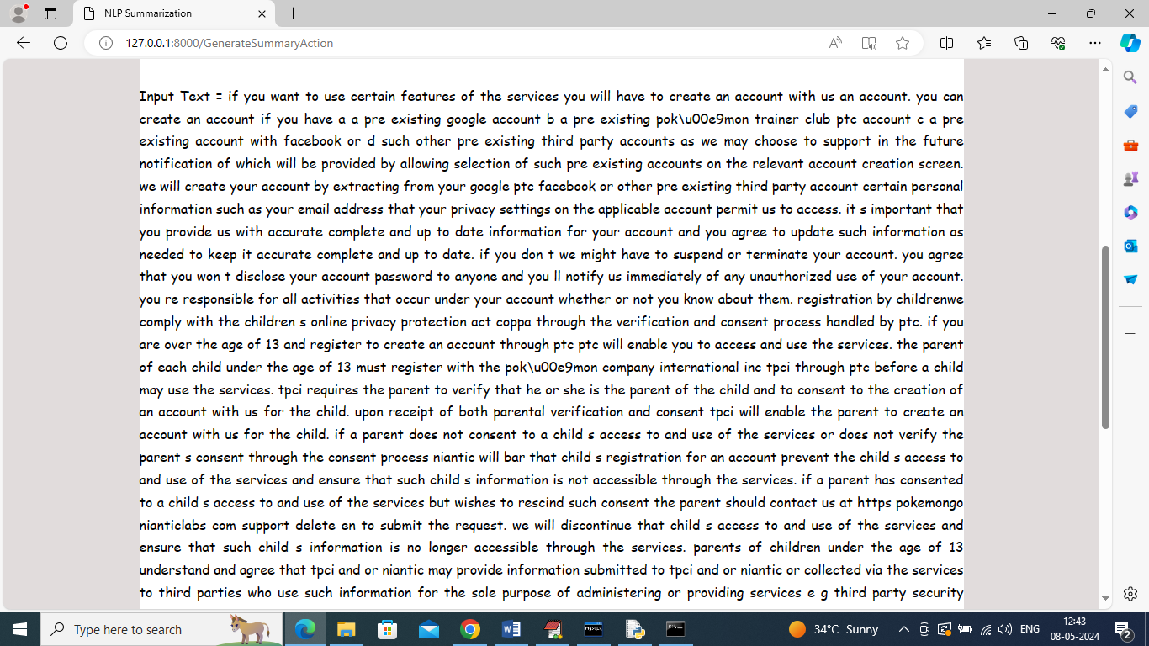
In above screen can see INPUT TEXT Data and below is the summary generated from above TEXT data
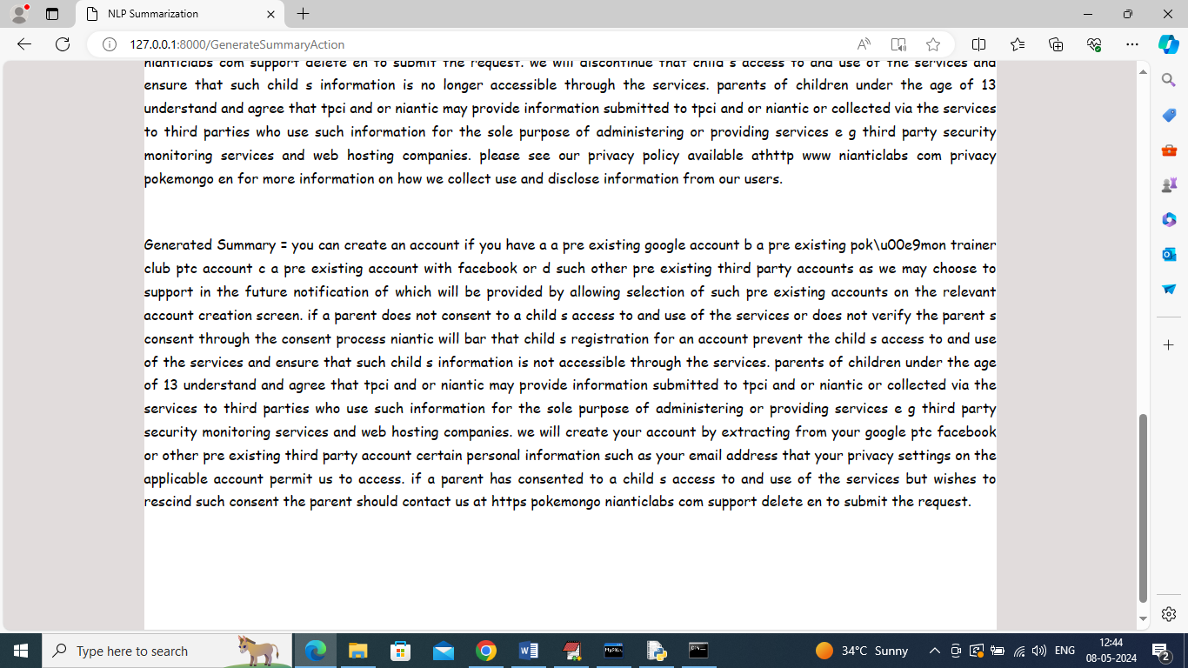
In above screen in second para can see generated summary from given long text and similarly you can give any text to get summary
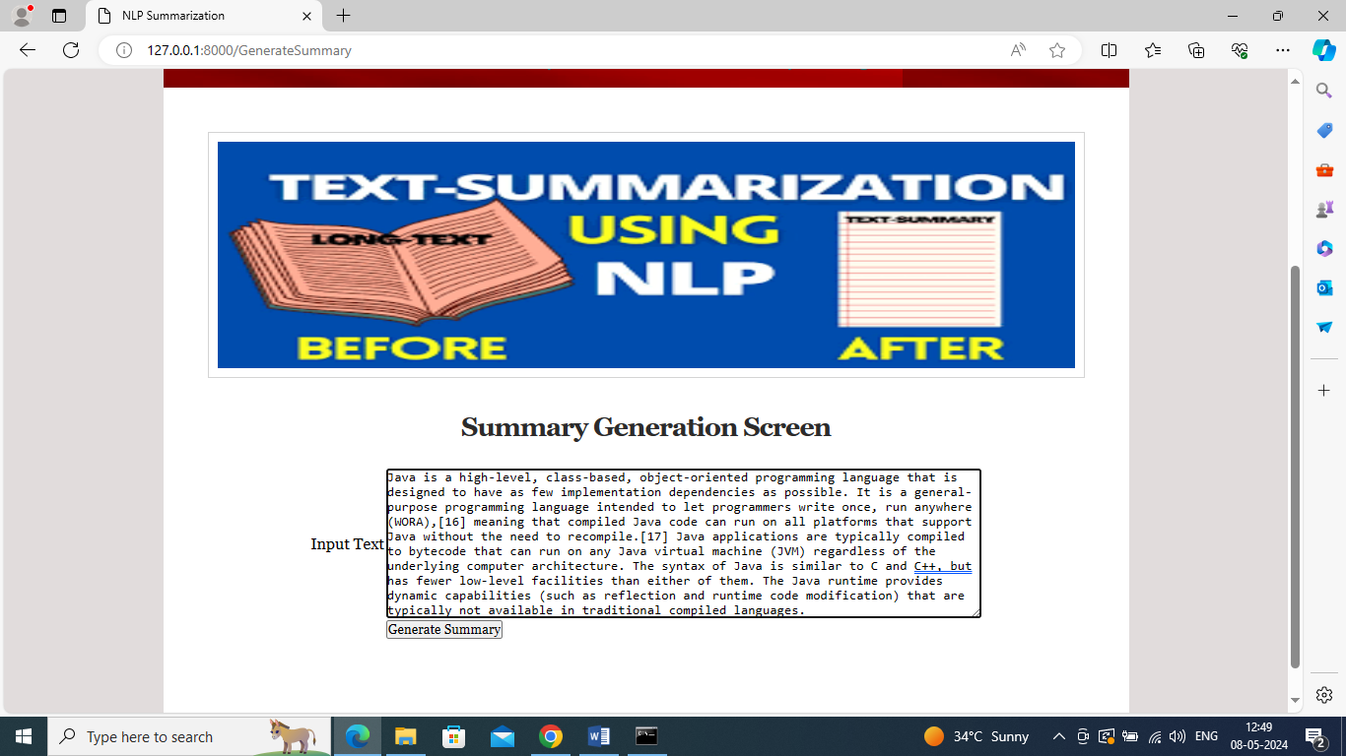
In above screen entered some other text and then click button to get below output
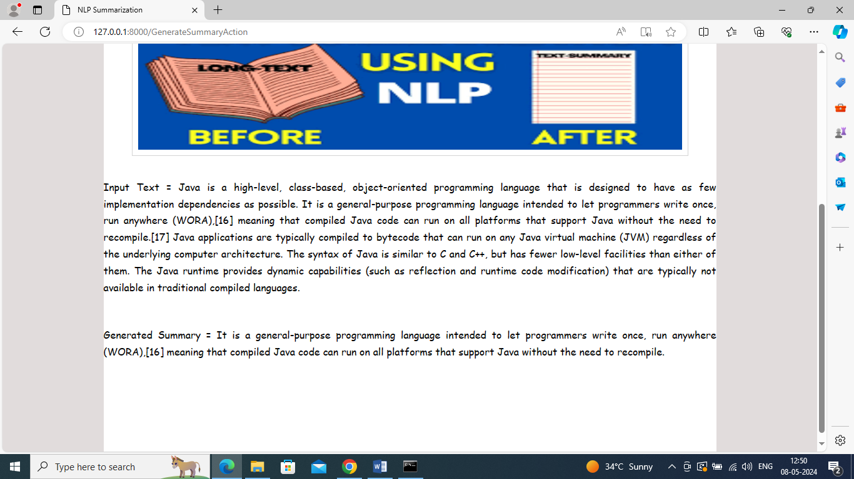
In above screen first para is the original INPUT TEXT and second para contains generated summary

8. CONCLUSION:
In this paper we presented a data driven semi-supervised approach to extractive legal document summarization using various neural network architectures. Our contribution is twofold – we proposed a novel technique of dataset generation using reference summary which eliminate the need for experts in such a complex domain and secondly, we propose a simple approach for generating legal document summarization without the need for feature crafting or domain knowledge. The proposed techniques perform well as measured by Rouge scores as well as result in coherent summaries. Our approach proceeds along two main stages – generation of labelled datasets for the task of classification/prediction of sentence importance and using various deep learning models on the training data to condense the essential components of the document into a summary. We proposed four approaches for the generation of labelled data and further demonstrated that using sentence embedding outperformed other three approaches. For the classification/prediction task the LSTM based NN architecture outperformed the other methods in most cases. In future we intend to perform the evaluation of the proposed method on legal text summaries generated by human experts. Court judgments are written using specific terminology and distinguished writing styles and hence tend to contain very lengthy and complex sentences. We intend to explore sentence simplification approaches for summaries thus obtained to enhance the interpretability of complex and long sentences
9. REFERENCES:
- General purpose unsupervised sentence representations. Retrieved from https://github.com/epfml/sent2vec.
Google Scholar
- Infersent Sentence Embedding, xxxx
Infersent Sentence Embedding. Retrieved from https://github.com/facebookresearch/InferSent.
Google Scholar
- Kanapala et al., 2019
A. Kanapala, S. Pal, R. Pamula
Text summarization from legal documents: a survey
Artif. Intell. Rev., 51 (3) (2019), pp. 371-402
View at publisher
CrossRefView in ScopusGoogle Scholar
- Kasture et al., 2014
N.R. Kasture, N. Yargal, N.N. Singh, N. Kulkarni, V. Mathur
A survey on methods of abstractive text summarization
Int. J. Res. Merg. Sci. Technol, 1 (6) (2014), pp. 53-57
Google Scholar
- Kavila et al., 2013
S.D. Kavila, V. Puli, G.P. Raju, R. Bandaru
An automatic legal document summarization and search using hybrid system
Proceedings of the International Conference on Frontiers of Intelligent Computing: Theory and Applications (FICTA), Springer, Berlin, Heidelberg (2013), pp. 229-236
View at publisher
CrossRefView in ScopusGoogle Scholar
- Keras, xxxx
Keras: The Python Deep Learning library. Retrieved from https://keras.io/.
Google Scholar
- Kim et al., 2012
M.Y. Kim, Y. Xu, R. Goebel
Summarization of legal texts with high cohesion and automatic compression rate
JSAI International Symposium on Artificial Intelligence, Springer, Berlin, Heidelberg (2012), pp. 190-204
View in ScopusGoogle Scholar
- Lin, 2004
Lin, C.Y., 2004. Rouge: A package for automatic evaluation of summaries. In Text summarization branches out. pp. 74–81.
Google Scholar
- Long Short Term Memory, xxxx
Long Short Term Memory. Retrieved from http://primo.ai/index.php?title=Long_Short-Term_Memory_(LSTM).
Google Scholar
- Oufaida et al., 2014
H. Oufaida, O. Nouali, P. Blache
Minimum redundancy and maximum relevance for single and multi-document Arabic text summarization
J. King Saud Univ. Comput. Inf. Sci., 26 (4) (2014), pp. 450-461
View PDFView articleView in ScopusGoogle Scholar
- Özateş et al., 2016
Ş.B. Özateş, A. Özgür, D. Radev
Sentence similarity based on dependency tree kernels for multi-document summarization
Proceedings of the Tenth International Conference on Language Resources and Evaluation (LREC'16) (2016), pp. 2833-2838
View in ScopusGoogle Scholar
- Pagliardini et al., 2017
Pagliardini, M., Gupta, P., Jaggi, M., 2017. Unsupervised learning of sentence embeddings using compositional n-gram features. arXiv preprint arXiv:1703.02507.
Google Scholar
- Polsley et al., 2016
S. Polsley, P. Jhunjhunwala, R. Huang
Casesummarizer: a system for automated summarization of legal texts
Proceedings of COLING 2016, the 26th International Conference on Computational Linguistics: System Demonstrations (2016), pp. 258-262
View in ScopusGoogle Scholar
- Saravanan et al., 2008
M. Saravanan, B. Ravindran, S. Raman
Automatic identification of rhetorical roles using conditional random fields for legal document summarization
Proceedings of the Third International Joint Conference on Natural Language Processing: Volume-I (2008)
Google Scholar
- Sinha et al., 2018
Sinha, A., Yadav, A., Gahlot, A., 2018. Extractive text summarization using neural networks. arXiv preprint arXiv:1802.10137.
Google Scholar
- Soares and Parreiras, 2018
M.A.C. Soares, F.S. Parreiras
A literature review on question answering techniques, paradigms and systems
J. King Saud Univ. Comput. Inf. Sci. (2018)
Google Scholar
- Steinberger and Ježek, 2012
J. Steinberger, K. Ježek
Evaluation measures for text summarization
Comput. Inf., 28 (2) (2012), pp. 251-275
Google Scholar
- Tokenizer spaCy API Documentation, xxxx
Tokenizer spaCy API Documentation. Retrieved from https://spacy.io/api/tokenizer.
Google Scholar
- Understanding LSTM Networks, 2015
Understanding LSTM Networks. Retrieved from https://colah.github.io/posts/2015-08-Understanding-LSTMs.
Google Scholar
- Venkatesh, 2013
R.K. Venkatesh
Legal documents clustering and summarization using hierarchical latent Dirichlet allocation
IAES Int. J. Artif. Intell., 2 (1) (2013)

